The Digital Divide 3

Access vs. Status 3

Internet Access 4

Consider This 5

Indigenous Community Engagement 6

Nations not Race 6

Language 6

The Four R’s 7

Gift Economy 7

Indigenous Acknowledgement 7

Logistics 7

Location 7

Transportation 7

Languages 8

Food 8

Words That Mean Things 9

Frequently Asked Questions 12

Isn’t noticing gender and race part of the problem? 12

What’s the fascination with food? 12

What if I keep using incorrect gender pronouns? Or what if I keep referring to groups as “guys”? 12

Quick Tips (ChickTech-bot is always here to offer advice)

Find out the demographics of the area, and then compare them to the demographics of your chapter; are ratios similar? The goal is for the leadership team reflect the community it is in. 5

Some communities have strong spiritual connections. The Western cultural norm is to separate spirituality from the organization. First Nation communities have sacred traditions and spirituality that is going to be inherent in their approach to education and intelligence. This cannot be belittled or labeled inappropriate. 6

Invite tribal leaders to the opening and closing ceremonies. They may wish to speak. 8

Connect with native tribes for language-related assistance. 9

Ask the community to help with food preparation. Connect with native tribes for information about Traditional Foods and their preparations. 9

## The Digital Divide

The [digital divide](https://en.wikipedia.org/wiki/Digital_divide) is an ongoing, shifting conversation where nuance is demanded. The United Nations declared internet access a basic human right, yet there are growing barriers keeping many people from having this right.

### Access vs. Status

The discussion around technological access is often in binary terms such as demonstrated by this image:

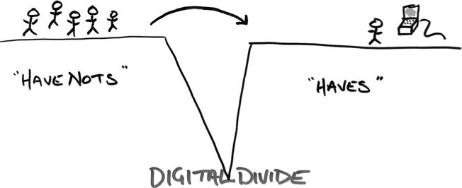

Despite the prevailing thought of a complete divide between the haves and have-nots, low-income community members often describe their lives as being

characterized by technological ubiquity—technology shapes their workplaces, community institutions, and political experiences. But, unlike many of their middle-class counter-parts, their encounters with IT and the high-tech economy tend to be exploitative and limiting, increasing their economic vulnerability and political marginalization. (Digital Dead End xix)

Urban working-class women further developed a collaborative rendering of the way the digital divide is manifesting within society from their experiences. The below image is a more complete, though in no way fully inclusive, concept of the digital divide from the perspective of those on the “have-not” side of the supposed equation. This is an [excerpt](https://drive.google.com/file/d/1Umn9sPm38wKed1EhYIHIvI1VdZe4ZaPx/view?usp=sharing) from Eubank’s book for those it may interest.

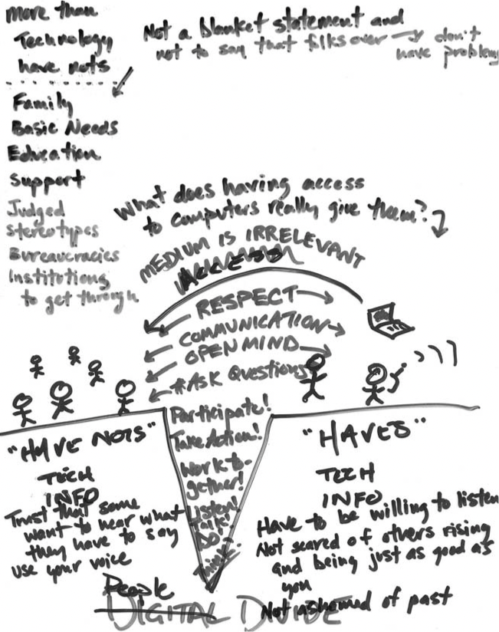

### Internet Access

Programs should be built with the understanding that broadband internet access is unlikely to be available. Yet given the global penetration of mobile phones, and the surge of smartphone focused development, community members may more readily have access to the internet over cellular data.

Therefore, chapters should have hardcopy of any forms or other documentation that needs to be seen or fill out by the community, and the ability to turn the hardcopy into digital.

### Consider This

Consideration: The experience marginalized populations have of work is that of low-paying, no-respect jobs classified as “low-skill,” despite not being so.

Solution(s): People need to be shown concrete examples of what the program can do, including expanding the communities’ notions of what work is and how employment works.

* Ask how your chapter can demonstrate the vast possibilities available to these students, and how the chapter can help disrupt the narrative that work is wage-slavery or that technology is only used to surveil and track.
* Demonstrate the possibilities of remote work; promote the idea that the technology industry isn’t inherent to moving to the city or leaving your community.

Find out the Demographics of the area, and then compare them to the demographics of your chapter; are ratios similar? The goal is for the leadership team to reflect the community it is in.

Consideration: Undocumented peoples, migrant workers, and Native American communities may be hesitant to allow their children to go off with unfamiliar organizations. The local and regional political-climate needs to be understood and incorporated into community partnerships.

Solution(s):

* Students can invite family members with them to participate, such as mothers, sisters, cousins, aunts, or grandmothers. Remember that there are cultures where family is based on tribe or clan as much as bloodline.
* Indigenous communities may have men in public leadership roles, yet as a cultural norm they cannot be welcomed as leaders without strong women advisors and demonstrating their ability to service the community; ask for the guidance of Indigenous women advisors.[1] In American Indian households 21% are headed by women. (See Below: The Four R’s)

Consideration: Rural populations may not have access to the digital technology that is normalized in contemporary society, but that doesn’t mean they are technology poor. This furthers the digital divide conversation.

Solution(s): Computer technology is mechanical, based in matter and the material, just as much as it is virtual. Demystifying technology is an important facet of ChickTech’s work.

* Does the local community have electricians, construction workers, mechanics, or handypeople? They have valuable, transferrable skills and more ready access to their technology. They are the “blue-collar” reflection of engineers, architects, physicists and technicians.
* Old video game systems, such a Nintendo NES/SNES and Atari, can be great to tear down and pick apart.

* Indigenous Knowledges framework
* Gamification

Consideration: Being “[off-grid](https://en.wikipedia.org/wiki/Off-the-grid)” can be beneficial for some populations, especially [those who experience increased surveillance through technology](http://strangehorizons.com/fiction/liminal-grid/).

Some communities have strong spiritual connections. The Western cultural norm is to separate spirituality from the organization. First Nation communities have sacred traditions, and spirituality, that are going to be inherent in their approach to education and intelligence. This cannot be belittled and is not inappropriate.[2]

## Indigenous Community Engagement[3]

### Nations not Race

Despite Native American’s being classified as a race under colonization, Indigenous tribes are nations.

* Do not put Native American classifications under race in surveys or data collection, instead ask if they are a tribal citizen. [Ask Dr. Tetuon, Dr. Ross]

### Language

1. Find out what the local Indigenous community calls themselves, and not the name that defined them through colonization. This name is how they should be referred to in all materials.
2. Know how to say basic phrases of the local Indigenous language(s).

### The Four R’s

Indigeneity is centered around four concepts: **relationship, responsibility, reciprocity, redistribution**. These are important to keep in mind when working with Native populations. It has been demonstrated that American Indian students do not find motivation in the traditional Western rhetoric of individual achievement. Instead, by contextualizing the participant’s engagement within their community. (Harris and Wasilewski, Indigeneity, an alternative worldview: four R's (relationship, responsibility, reciprocity, redistribution) vs. two P's (power and profit). Sharing the journey towards conscious evolution)

#### Gift Economy

Gift giving is an important ceremony for establishing and maintaining relationships. Gifts should be meaning, and the ritual is the start of an ongoing relationship.

#### Connecting Tech to Community

It has been shown that Indigenous students aren’t encouraged by individual achievement, and instead need to link their future with their kin. Promoting this concept in your marketing materials, and in your interactions with Indigenous students will go a long way.w

### Indigenous Acknowledgement

As part of decolonizing we must recognize land is communally owned and protected by Indigenous populations and Native American tribes. Once you’ve found out the names of the people who are kin with the land, be sure to include an acknowledgement in your opening and closing ceremonies. Thank them for welcoming ChickTech into their space.

* Be sure to include resources for action. For example, a website where people can pay rent to the local tribes (http://rentforduwamish.com). Ask the communities if they have preferred resources.

Invite tribal leaders to the opening and closing ceremonies. They may wish to speak and welcome everyone to the land.

## Logistics

### Location

If you are in an area with a reservation, then connecting with them to see about a venue would be appropriate. Choosing a location that puts resources into the community would increase community engagement.

### Transportation

* Connect with local organizations, like churches, schools, and scout troops, early on.
* There may be carpools already established; also consider recreational centers, the Boys and Girls Club, and other community youth organizations. Transportation is likely to be an issue for all organizational programs in rural communities so there may be a network you can tap into.
* High schools may be willing to pull resources to rent a bus or van for their students if there are enough.
* Parents who are already driving their child(ren) would likely be open to carpooling. Though this would be something the parents need to arrange.

### Languages

Program materials should be available in multiple languages, based on the demographics of the community. Also, be aware of potential literacy issues; have information materials in other formats such as a video or audio recording. These would need to be available in alternative languages, and any videos should have subtitles.

[Connect with native tribes](#Indigenous Community Engagement) for language-related assistance.

### Food

ChickTech requires food to be provided at all their events, and the Rural program wanted to recruit kids in free/reduced food programs. There are free/reduced lunch programs *and* free/reduced breakfast programs, so you may need to provide both to students.

Be sure to be generous, and nutritious with what you serve. Children 13-years-old need up to [2,600 calories a day](https://www.mayoclinic.org/healthy-lifestyle/childrens-health/in-depth/nutrition-for-kids/art-20049335)[4].

Ask the community to help with food preparation. [Connect with native tribes](#Gift Economy) for information about Traditional Foods and their preparations.

## Words That Mean Things

#### Demographics

are statistical data about a population. In the context of ChickTech it will most always refer to US Census data including, but not limited to:

* + Gender
  + Race
  + Class (income level)
  + Nationality
  + Ethnicity

#### Indigenous Knowledges framework

* + Including traditional knowledge, native science, and traditional ecological knowledge; are complex, time-tested ways of knowing and interacting with the world that have sustained Indigenous and traditional cultures for millennia.
* Science is just ways of knowing that explain the world with culturally specific institutions and theories that include theoretical, practical, and applied knowledge
* Traditional Ecological Knowledge (TEK) is not unchanging knowledge, but hard-earned, empirical knowledge Indigenous peoples have and continue to develop through their relationships with their homelands.

#### education [5]

* American higher education (i.e, Harvard and Dartmouth) began with an intent to educate Native Americans. The education of American Indians was understood as a key goal of the early U.S. republic—it was thought its success would demonstrate American progressive ideals.
* Early treaties included provisions for government support of schools on tribal lands. In the late 19th century, Native American colleges were established: Bacone College and Pembroke State, later UNC Pembroke.
* Government boarding schools based on military models were established: Carlisle Academy, 1879.
* Many schools were on tribal lands: in 1903, there were 221 of these government schools on reservations. These schools were determined to be providing an inadequate education: poorly funded; focused on vocational and technical education; religious in orientation; and assimilative in intent. They did not provide the educational tools for tribal nations to become self-sustaining.

#### Progress

* + From 16th century through the mid-20th century, Euro-American education of Native Americans sought to teach “civilization” and “salvation.”
  + “From an indigenous perspective, in order to care for the earth and our bodies, we must keep the traditional teachings alive. […] During times of cultural education crisis, activist must create new structures of teaching and learning, using what Denise Nadeau and Alannah Earl Young have described as an ‘Indigenous Knowledges framework’ that includes traditional knowledge systems and practices as well as contemporary forms of knowledge that teach about ‘Indigenous theory, values, and cosmology, and provide an embodied connection to relations” (*Yakama Rising*, 9 - 10)
  + “When the religious right tried to destroy religious freedom by placing God in the Constitution and prayer in public schools and by pushing a conservative political agenda in the 1890s, Stanton and Gage (Mott had died) determined to challenge the church. Their theory held that indigenous women in early history held positions of respect and authority in egalitarian and woman-centered societies that often worshiped a female deity, sometimes in combination with a male consort. This matriarchal system was overthrown, Stanton contended, when “Christianity, putting the religious weapon into man’s hand, made his conquest complete.”22 While common knowledge held that Christianity and civilization meant progress for women, Stanton and Gage disagreed.” (*Sisters in Spirit,* 49-50)

#### The Four R’s (Harris and Wasilewski)

* + Relationship: The *kinship obligation* between a person and everything around them. It means that everything is a blood-relative, and so every member of the community is to be made to feel valuable, and everyone and everything is felt to have a contribution to make.
  + Responsibility: A *community obligation* to not only care for each other but working to create environments (literally and figuratively) that allow the roles we fill to be engendered.
  + Reciprocity: The *cyclical obligation* of exchange. Once an Indigenous person encounters another, they are in a relationship with them that makes them kin. There is not a responsibility to care for the other.
  + Redistribution: The *sharing obligation* cultural norm that centers generosity. Wealth is not the accumulation of goods but in the giving. When marking accomplishments an individual will give gifts rather than receive them. It is not just about the material, but emotional labor, compassion, time, knowledge, talent, and so forth.

## Frequently Asked Questions

#### Isn’t noticing gender and race part of the problem?

Acknowledging and making space for difference is not the problem. Racism, sexism, and other oppressive power systems are the problem. Universality (there being singular experiences and ways of being) is a colonial concept that requires unpacking. ChickTech believes in respecting others, and that includes seeing them as whole people.

#### What’s the fascination with food?

Organizing has a long history of providing for communities that are food-scarce [The Black Panthers are in part responsible](https://www.aaihs.org/the-black-panther-party/) for the [federal breakfast program](https://www.history.com/news/free-school-breakfast-black-panther-party), and the General Strike Committee for the 1919 Seattle Workers' Strike set up [31 kitchens](https://www.socialistalternative.org/2017/08/20/workers-ran-seattle-lessons-1919-general-strike/) to feed the union, and community, members.

#### What if I keep using incorrect gender pronouns? Or what if I keep referring to groups as “guys”?

That’s ok.

You are going to make mistakes. We all do. Gender is hard and learning new conventions can be a struggle. There are 3 things to do:

1. Correct yourself without drama.
2. Apologize when it is an appropriate time.
3. Keep reflecting and doing better.

It is a step forward to recognize when you make mistakes and is one of the harder parts of growing and adapting as a person.

#### How can I find out more?

Reach out to your local tribes.

The [Indigenous Information Research Group](https://iirg.ischool.uw.edu/) at the University of Washington can be a resource for the Pacific Northwest and may have contacts across the nation that would be useful.

1. *Yakama Rising*, 110
2. *Yakama Rising*, 115
3. This guide addresses Rural populations; remember there are Urban Indigenous communities and therefore urban outreach could be improved with this framework.
4. The separation of gender likely should be ignored since we understand biological essentialism is not valid in this context.
5. Dr. Christopher Teuton, Professor of American Indian Studies at University of Washington